Technical Story Card

Revision History

|  |  |  |  |
| --- | --- | --- | --- |
| Version No. | Date | Prepared by / Modified by | Significant Changes |
| 1 | 10/2/2022 | Bhavish | Draft version |
| 1.1 | 10/2/2022 | Bhavish | Reworked based on Review comments |
| 1.2 | 10/2/2022 | Bhavish | Reworked based on Review comments |

Glossary

|  |  |
| --- | --- |
| Abbreviation | Description |
| UI | User Interface |
| DB | Database |
| UML | Unified Modeling Language |
| DD | Detailed Design |

## Introduction

* Online rental hub is a web application developed to gadget a website for different cities to show homes which are for rents. Rental hub provides service to rent or own a house. Rental hub provides direct communication between customer and the vendor and maintain the database.
* This application acts as an interface between the vendor and the rental showroom owner.
* The application provides an extra feature of relocating the service.
* This project includes modules such as: -

1.Sign up

2.Admin login

3.login

4.Homes pages

5.location

6.feedback

7.best offers

8.Filter page

# Design and Detailed technical updates

## Process model

### Use case Model

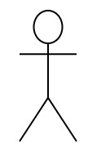

|  |  |
| --- | --- |
| Brief Description | **Sign in** |
| **Basic Flow** | 1. Click on the sign in tab. 2. Enter the credentials of the user. 3. The Sign in page details are displayed as follows:      * User name/User Id * Password * Forget User name/User Id * Forget Password * Login |
| **Alternate Flow** | If the user gives Wrong user id or password, then it display “User id or Password is incorrect” and display options  Forget User name/User Id or Forget Password. |
| **Validation** | User must give correct user id and password. After giving credentials the page identifies the person is a Admin or a User. |
| **Pre-Conditions** | User must give the login credentials to log in. |
| **Post-Conditions** | User will get user profile dashboard or Admin profile dashboard. |

**UI Screen Flow**



|  |  |
| --- | --- |
| **Brief Description** | **Login Page** |
| **Basic Flow** | 1. Search for website and click on the page link. 2. Look at the login page appears on the web page. 3. The login page details are displayed as follows:      * Sign in * Sign up |
| **Alternate Flow** | If the user does not select Sign in or Sign up from the Login page and directly click on enter button, then it does not move to any page and stay on the same page. |
| **Validation** | User must click on any one of the option like sign in or sign up. otherwise it will does not move to any page and stay on the same page. |
| **Pre-Conditions** | User needs to select the Sign in or sign up from the login page. |
| **Post-Conditions** | * If user selects Sign in, then sign in page will open. * If user selects Sign up, then sign up page will open. |



|  |  |
| --- | --- |
| Brief Description | **Home page** |
| **Basic Flow** | 1.Display the home page.  2.Select the item that user want to explore.  3.Display the user selected item. |
| **Alternate Flow** | ------------------------------- |
| **Validation** | If user login in website then it will display home page otherwise it will not display anything to user. |
| **Pre-Conditions** | User must as to be login in to see the home page otherwise it doesn’t display anything. |
| **Post-Conditions** | If user click the selected item on home page it will direct what user want to looking for. |

**UI Screen Flow**

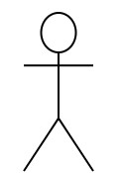





|  |  |
| --- | --- |
| **Brief Description** | **Filter Page** |
| **Basic Flow** | 1.Click on the Filter tab.          2.User needs to select from the drop down menu:   * Sort by price * Sort by area   3.The selected page details are displayed. |
| **Alternate Flow** | If the user doesn’t select from drop down menu the page remains same. |
| **Validation** | Validate all the filters given by the user. |
| **Pre-Conditions** | Search filters |
| **Post-Conditions** | Apply filters. |

**UI Screen Flow**



|  |  |
| --- | --- |
| **Brief Description** | **Feedback** |
| **Basic Flow** | 1. Click on Feedback tab 2. Fill the Feedback form 3. Give your Rating based on your experience  * Select Stars for giving Rating. * Use the text box to express your views. * Give suggestion to Improve the Service. |
| **Alternate Flow** | The user has to select on the Feedback tab to give feedback on service otherwise the page doesn’t get redirected |
| **Validation** | All the fields are mandatory and must be filled. Otherwise feedback cannot be saved and results in validation error. |
| **Pre-Conditions** | User needs to select the appropriate rating buttons based on his interest and feedback should be given. |
| **Post-Conditions** | User given feedback is successfully stored to Database. |

**UI Screen Flow**



|  |  |
| --- | --- |
| **Brief Description** | **Location Page** |
| **Basic Flow** | 1. Click on Location tab 2. User need to search where he wanted a house. 3. The Location page details are displayed as following:  * House number * Area name * City * country |
| **Alternate Flow** | If area name doesn’t match it will returns error. |
| **Validation** | Check the entered area number is correct or not. |
| **Pre-Conditions** | User needs to enter area name. |
| **Post-Conditions** | Display the location of the House in which the user has searched. |

**Technical Architecture Diagram**

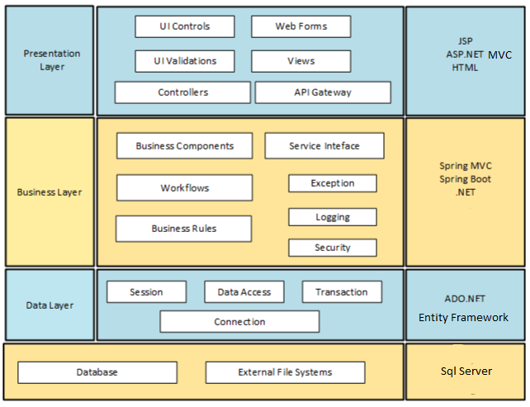

The user gets an interactive user interface through which he/she will be able to choose their house. As soon as the user enters the website by providing a valid URL he/she gets a dashboard where they can choose which type of houses they are looking for. As soon as the user choose the required department he/she has to provide some details like name or city or pin code of the area of the department you are looking for. If the details provided by user is correct then it displays whole details of the department you want to search.

|  |  |  |
| --- | --- | --- |
| Layer | Component | Example(s) |
| Presentation Layer | Views |  |
| Business Layer | Business components |  |
| Data Layer | Transaction |  |

**Presentation Layer**

The presentation layer has two main parts:

a) Client side code and b) Server side code.

The client side code store data from server (if needed) and does validation of input parameters. It also collects meta data information of the client which will be used by the application. The server side code is responsible for the UI components displayed on the screen. It interacts with the “Business Layer” which contains the business logic

Various Components in this layer are:

C.1.1. UI Controls: Interactive components in user interface like buttons, Dropdown List, etc.

C.1.2. Web Forms: Forms with various fields to submit data to the server.

C.1.3. UI Validations: Validations to be done at UI level. E.g. Number validation, Type validation, etc.

C.1.4. Controllers: User interface (UI) controllers serve as a connection between your UI and any business logic in your application that controls, or is instructed by, that UI

C.1.5. Views: Basic building block of UI. Customized for each screen or page.

**Business Layer**

This layer has the business logic. It collects data from the Presentation Layer, receives the request from the client, processes the requests, connects to the database layer if needed and sends the response back to the presentation layer.

Various Components in this layer are:

C.1. Workflows: A Workflow is a sequence of tasks that processes a set of data.

C.2. Business Rules: A business rule defines or constrains some aspect of business and always resolves to either true or false.

C.4. Logging: It is an API that provides the ability to trace out the errors of the applications. When an application generates the logging call, the Logger records the event in the Log Record.

**Data Layer**

This layer will access the data stored in the database and files. When the “Business Layer” requests for information, it searches the tables in the database and provides the information. It also stores the data for each session. It stores the log of all the steps followed by the user in a given session.

Various Components in this layer are:

C.3.1. Session: It represents the connection between an application and the relational database that stores its persistent objects.

C.3.2. Data Access: It is a pattern that provides an abstract interface to some type of database or other persistence mechanism. By mapping application calls to the persistence layer, the DAO provides some specific data operations without exposing details of the database.

C.3.4. Connection: A Database connection is a facility in computer science that allows client software to talk to database server software, whether on the same machine or not. A connection is required to send commands and receive answers, usually in the form of a result set.

# Sequence diagram

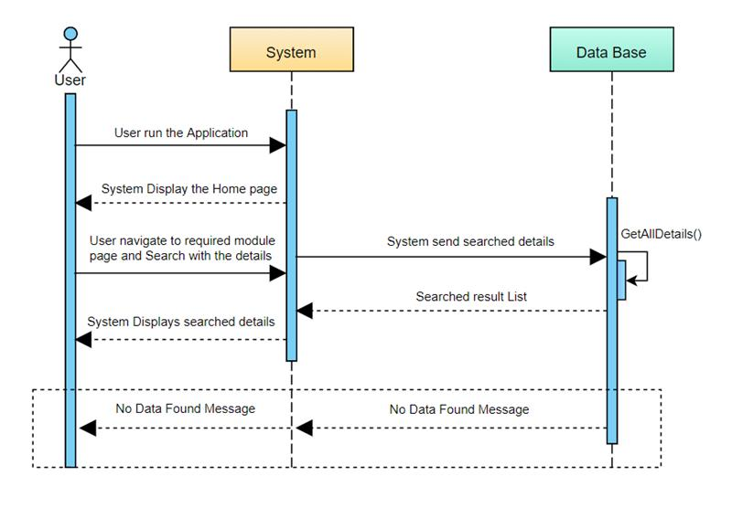

# ER Diagram for database Design

|  |
| --- |
| Sign up |
| **User ID(P)** |
| **Create Password** |
| **Retype-Password** |
| **Email(F)** |

|  |
| --- |
| Admin |
| **Admin Username(P)** |
| **Password** |
| **Retype-Password** |
| **Email(F)** |

|  |
| --- |
| Home Page |
| **Search Page** |
| **Profile** |
| **Update** |
| **Remove** |
| **Location** |
| **Offers** |
| **Filters** |
| **Settings** |
| **Logout(F)** |
| **About Us** |

|  |
| --- |
| Location |
| **Country** |
| **State** |
| **District** |
| **City** |
| **Landmark** |
| **Pin code** |

|  |
| --- |
| Login |
| **Login Id (P)** |
| **Password** |

|  |
| --- |
| Offers |
| Cashback |
| Flat Discount |

|  |
| --- |
| Logout |
| Logout |

|  |
| --- |
| Filter |
| Sort By Price |
| Sort By Area |

|  |
| --- |
| About Us |
| Info |

# Non-functional Requirements and Design

* Online rental hub is a web application developed to gadget a website for different cities to show homes which are for rents.
* Rental hub provides service to rent or own a house. Rental hub provides direct communication between customer and the vendor and maintain the database.
* This application acts as an interface between the vendor and the rental showroom owner.

# Additional notes to technical team

Technologies used in these project:

1. HTML 5
2. CSS
3. BOOTSTRAP v4
4. JQUERY
5. SQL
6. MVC
7. Validation
8. Session

# References

* <https://dotnet.microsoft.com/learn/csharp>
* <https://www.w3schools.com/css/default.asp>